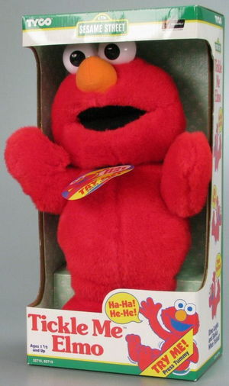
Tickle Me Elmo
Name:
- After reading the first paragraph of this article, why do you think adults were so crazy to get their hands on Tickle Me Elmo?

- Who do you think the well-known talk show personality was that started the craze to have Tickle Me Elmo for Christmas?

- Based on the article about this toy called Tickle Me Elmo, how would you define the following:
market:
demand:
supply:

- Why is the supply fixed and can not be changed in this case?

- Name three (3) factors that contributed to the demand for Tickle Me Elmo.

- How would you define “ speculative demand”?

- What other toy caused the same type of craze back in 1986?

